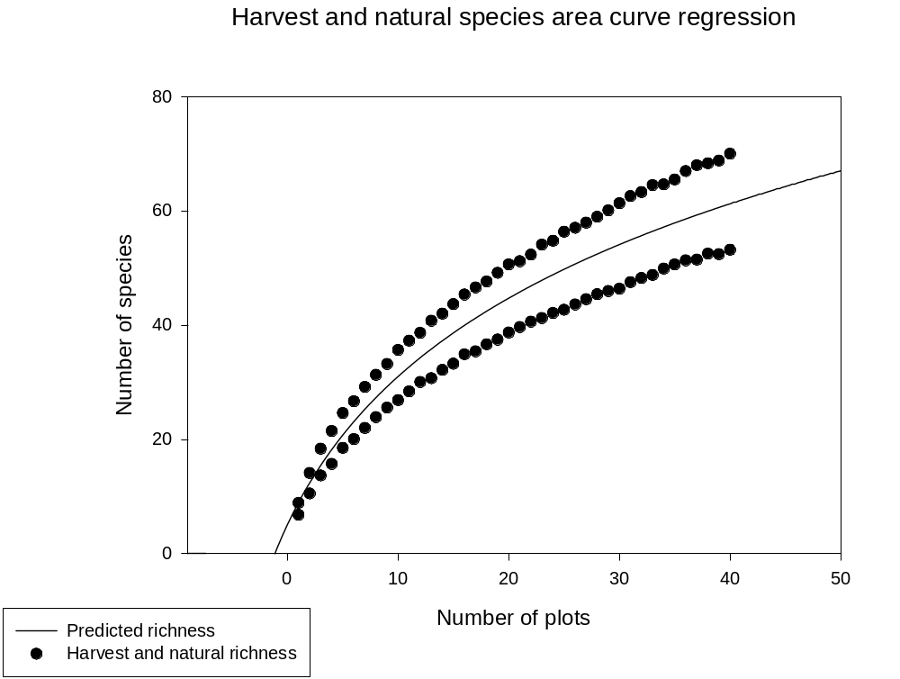

Harvest and natural richness
Nonlinear Regression

[Variables]
x = col(1)
y = col(2)
'Automatic Initial Parameter Estimate Functions
F(q)=ape(ln(x-x0est(q)),y,1,0,1)
x0est(q)=min(q) - 0.5
[Parameters]
a = F(0)[2] ''Auto {{previous: 30.0559}}
x0 = x0est(x) ' {{previous: -7.31219}}
y0 = F(0)[1] ' {{previous: -54.6734}}
[Equation]
f=if(x-x0>0, y0+a*ln(abs(x-x0)), 0)
fit f to y
[Constraints]
[Options]
tolerance=1e-4
stepsize=1
iterations=100

R = 0.92477124 Rsqr = 0.85520184 Adj Rsqr = 0.85144085

Standard Error of Estimate = 6.0917

Coefficient Std. Error t P
a 30.0559 5.9175 5.0792 <0.0001
x0 -7.3122 3.7999 -1.9243 0.0580
y0 -54.6734 24.0975 -2.2688 0.0261

Analysis of Variance:
DF SS MS F P
Regression 2 16876.3015 8438.1508 227.3874 <0.0001
Residual 77 2857.4042 37.1091
Total 79 19733.7057 249.7937

PRESS = 3042.2738

Durbin-Watson Statistic = 0.0473

Normality Test: Failed (P = <0.0001)

Constant Variance Test: Failed (P = <0.0001)

Power of performed test with alpha = 0.0500: 1.0000

Regression Diagnostics:
Row Predicted Residual Std. Res. Stud. Res. Stud. Del. Res.
1 8.9768 -0.0968 -0.0159 -0.0180 -0.0179
2 12.3912 1.7188 0.2822 0.3009 0.2992
3 15.4570 2.9030 0.4766 0.4949 0.4925
4 18.2388 3.2412 0.5321 0.5459 0.5434
5 20.7848 3.8252 0.6279 0.6407 0.6383
6 23.1319 3.5581 0.5841 0.5947 0.5922
7 25.3089 3.8611 0.6338 0.6449 0.6424
8 27.3388 3.9612 0.6503 0.6615 0.6590
9 29.2402 3.9598 0.6500 0.6612 0.6588
10 31.0285 4.6515 0.7636 0.7766 0.7746
11 32.7163 4.5437 0.7459 0.7584 0.7563
12 34.3144 4.3556 0.7150 0.7267 0.7244
13 35.8317 4.9383 0.8107 0.8233 0.8216
14 37.2761 4.7139 0.7738 0.7853 0.7834
15 38.6543 5.0257 0.8250 0.8366 0.8349
16 39.9721 5.3779 0.8828 0.8944 0.8933
17 41.2345 5.3555 0.8791 0.8899 0.8887
18 42.4460 5.2040 0.8543 0.8640 0.8626
19 43.6105 5.5495 0.9110 0.9207 0.9198
20 44.7316 5.9184 0.9715 0.9812 0.9810
21 45.8124 5.3676 0.8811 0.8894 0.8882
22 46.8557 5.4843 0.9003 0.9084 0.9073
23 47.8640 6.2360 1.0237 1.0326 1.0330
24 48.8395 5.9105 0.9702 0.9785 0.9782
25 49.7844 6.5556 1.0762 1.0853 1.0866
26 50.7005 6.3395 1.0407 1.0497 1.0504
27 51.5894 6.3406 1.0408 1.0503 1.0510
28 52.4529 6.5171 1.0698 1.0800 1.0812
29 53.2922 6.8178 1.1192 1.1306 1.1327
30 54.1087 7.2313 1.1871 1.2002 1.2037
31 54.9036 7.6764 1.2601 1.2754 1.2807
32 55.6781 7.6119 1.2496 1.2662 1.2713
33 56.4330 8.0870 1.3275 1.3471 1.3544
34 57.1695 7.4705 1.2263 1.2463 1.2509
35 57.8884 7.5916 1.2462 1.2687 1.2738
36 58.5905 8.3795 1.3756 1.4029 1.4120
37 59.2765 8.7035 1.4287 1.4601 1.4711
38 59.9472 8.3728 1.3744 1.4077 1.4169
39 60.6033 8.1767 1.3423 1.3780 1.3862
40 61.2454 8.7446 1.4355 1.4774 1.4890
41 8.9768 -2.1868 -0.3590 -0.4061 -0.4039
42 12.3912 -1.8612 -0.3055 -0.3259 -0.3240
43 15.4570 -1.7870 -0.2933 -0.3047 -0.3029
44 18.2388 -2.5288 -0.4151 -0.4259 -0.4236
45 20.7848 -2.2848 -0.3751 -0.3827 -0.3806
46 23.1319 -3.0719 -0.5043 -0.5134 -0.5109
47 25.3089 -3.3189 -0.5448 -0.5543 -0.5518
48 27.3388 -3.4488 -0.5661 -0.5759 -0.5734
49 29.2402 -3.6802 -0.6041 -0.6145 -0.6120
50 31.0285 -4.1485 -0.6810 -0.6926 -0.6903
51 32.7163 -4.3063 -0.7069 -0.7188 -0.7165
52 34.3144 -4.2744 -0.7017 -0.7131 -0.7108
53 35.8317 -5.1217 -0.8408 -0.8539 -0.8524
54 37.2761 -5.1261 -0.8415 -0.8540 -0.8525
55 38.6543 -5.4043 -0.8872 -0.8996 -0.8985
56 39.9721 -5.0721 -0.8326 -0.8436 -0.8420
57 41.2345 -5.8145 -0.9545 -0.9662 -0.9658
58 42.4460 -5.8060 -0.9531 -0.9640 -0.9635
59 43.6105 -6.1405 -1.0080 -1.0188 -1.0190
60 44.7316 -6.0116 -0.9869 -0.9967 -0.9967
61 45.8124 -6.1424 -1.0083 -1.0178 -1.0180
62 46.8557 -6.2557 -1.0269 -1.0361 -1.0366
63 47.8640 -6.6140 -1.0857 -1.0951 -1.0966
64 48.8395 -6.7095 -1.1014 -1.1108 -1.1125
65 49.7844 -7.0944 -1.1646 -1.1745 -1.1775
66 50.7005 -7.0805 -1.1623 -1.1724 -1.1753
67 51.5894 -7.0494 -1.1572 -1.1677 -1.1705
68 52.4529 -7.0429 -1.1561 -1.1672 -1.1700
69 53.2922 -7.3222 -1.2020 -1.2143 -1.2181
70 54.1087 -7.7087 -1.2654 -1.2795 -1.2849
71 54.9036 -7.4036 -1.2154 -1.2301 -1.2343
72 55.6781 -7.4281 -1.2194 -1.2356 -1.2399
73 56.4330 -7.6630 -1.2579 -1.2765 -1.2818
74 57.1695 -7.2795 -1.1950 -1.2144 -1.2182
75 57.8884 -7.2784 -1.1948 -1.2163 -1.2202
76 58.5905 -7.2505 -1.1902 -1.2139 -1.2177
77 59.2765 -7.8065 -1.2815 -1.3096 -1.3159
78 59.9472 -7.4372 -1.2209 -1.2504 -1.2551
79 60.6033 -8.1833 -1.3434 -1.3791 -1.3874
80 61.2454 -8.0754 -1.3256 -1.3643 -1.3721

Influence Diagnostics:
Row Cook'sDist Leverage DFFITS
1 0.0000 0.2187 -0.0095
2 0.0042 0.1210 0.1110
3 0.0064 0.0730 0.1382
4 0.0052 0.0500 0.1246
5 0.0056 0.0395 0.1295
6 0.0043 0.0353 0.1133
7 0.0049 0.0339 0.1204
8 0.0051 0.0336 0.1229
9 0.0051 0.0335 0.1227
10 0.0069 0.0333 0.1438
11 0.0065 0.0327 0.1391
12 0.0058 0.0318 0.1313
13 0.0071 0.0306 0.1460
14 0.0062 0.0291 0.1357
15 0.0066 0.0275 0.1404
16 0.0071 0.0258 0.1454
17 0.0065 0.0241 0.1397
18 0.0057 0.0225 0.1308
19 0.0061 0.0210 0.1346
20 0.0064 0.0196 0.1389
21 0.0050 0.0185 0.1221
22 0.0049 0.0177 0.1217
23 0.0062 0.0171 0.1362
24 0.0055 0.0168 0.1279
25 0.0067 0.0168 0.1421
26 0.0064 0.0172 0.1388
27 0.0067 0.0178 0.1416
28 0.0075 0.0188 0.1498
29 0.0088 0.0202 0.1625
30 0.0107 0.0218 0.1798
31 0.0132 0.0238 0.2001
32 0.0144 0.0262 0.2084
33 0.0179 0.0288 0.2333
34 0.0170 0.0318 0.2266
35 0.0195 0.0351 0.2428
36 0.0264 0.0387 0.2831
37 0.0316 0.0425 0.3101
38 0.0324 0.0467 0.3137
39 0.0341 0.0512 0.3219
40 0.0431 0.0559 0.3624
41 0.0154 0.2187 -0.2137
42 0.0049 0.1210 -0.1202
43 0.0024 0.0730 -0.0850
44 0.0032 0.0500 -0.0971
45 0.0020 0.0395 -0.0772
46 0.0032 0.0353 -0.0978
47 0.0036 0.0339 -0.1034
48 0.0038 0.0336 -0.1069
49 0.0044 0.0335 -0.1140
50 0.0055 0.0333 -0.1281
51 0.0058 0.0327 -0.1318
52 0.0056 0.0318 -0.1289
53 0.0077 0.0306 -0.1514
54 0.0073 0.0291 -0.1477
55 0.0076 0.0275 -0.1511
56 0.0063 0.0258 -0.1370
57 0.0077 0.0241 -0.1518
58 0.0071 0.0225 -0.1461
59 0.0074 0.0210 -0.1491
60 0.0066 0.0196 -0.1411
61 0.0065 0.0185 -0.1399
62 0.0064 0.0177 -0.1391
63 0.0070 0.0171 -0.1446
64 0.0070 0.0168 -0.1454
65 0.0079 0.0168 -0.1540
66 0.0080 0.0172 -0.1553
67 0.0082 0.0178 -0.1577
68 0.0087 0.0188 -0.1621
69 0.0101 0.0202 -0.1747
70 0.0122 0.0218 -0.1919
71 0.0123 0.0238 -0.1928
72 0.0137 0.0262 -0.2032
73 0.0161 0.0288 -0.2208
74 0.0161 0.0318 -0.2207
75 0.0179 0.0351 -0.2326
76 0.0197 0.0387 -0.2442
77 0.0254 0.0425 -0.2773
78 0.0255 0.0467 -0.2778
79 0.0342 0.0512 -0.3222
80 0.0367 0.0559 -0.3339

95% Confidence:
Row Predicted Regr. 5% Regr. 95% Pop. 5% Pop. 95%
1 8.9768 3.3036 14.6500 -4.4145 22.3681
2 12.3912 8.1724 16.6100 -0.4517 25.2341
3 15.4570 12.1805 18.7334 2.8921 28.0219
4 18.2388 15.5274 20.9502 5.8093 30.6683
5 20.7848 18.3725 23.1971 8.4171 33.1525
6 23.1319 20.8525 25.4113 10.7894 35.4743
7 25.3089 23.0752 27.5425 12.9747 37.6430
8 27.3388 25.1149 29.5626 15.0064 39.6711
9 29.2402 27.0185 31.4619 16.9082 41.5722
10 31.0285 28.8146 33.2424 18.6979 43.3590
11 32.7163 30.5213 34.9113 20.3891 45.0435
12 34.3144 32.1504 36.4783 21.9927 46.6360
13 35.8317 33.7100 37.9534 23.5174 48.1461
14 37.2761 35.2061 39.3462 24.9706 49.5817
15 38.6543 36.6428 40.6658 26.3585 50.9502
16 39.9721 38.0237 41.9205 27.6864 52.2577
17 41.2345 39.3513 43.1177 28.9590 53.5100
18 42.4460 40.6275 44.2645 30.1802 54.7117
19 43.6105 41.8538 45.3673 31.3538 55.8673
20 44.7316 43.0313 46.4320 32.4829 56.9804
21 45.8124 44.1608 47.4641 33.5703 58.0545
22 46.8557 45.2429 48.4685 34.6188 59.0926
23 47.8640 46.2781 49.4499 35.6306 60.0974
24 48.8395 47.2672 50.4118 36.6079 61.0712
25 49.7844 48.2112 51.3576 37.5526 62.0162
26 50.7005 49.1114 52.2895 38.4666 62.9343
27 51.5894 49.9698 53.2091 39.3516 63.8273
28 52.4529 50.7884 54.1173 40.2090 64.6967
29 53.2922 51.5698 55.0146 41.0403 65.5440
30 54.1087 52.3165 55.9009 41.8468 66.3706
31 54.9036 53.0311 56.7761 42.6298 67.1775
32 55.6781 53.7162 57.6399 43.3903 67.9659
33 56.4330 54.3741 58.4919 44.1294 68.7367
34 57.1695 55.0071 59.3320 44.8481 69.4909
35 57.8884 55.6170 60.1598 45.5474 70.2294
36 58.5905 56.2057 60.9752 46.2281 70.9528
37 59.2765 56.7747 61.7783 46.8910 71.6620
38 59.9472 57.3255 62.5690 47.5370 72.3575
39 60.6033 57.8593 63.3474 48.1667 73.0400
40 61.2454 58.3772 64.1136 48.7808 73.7101
41 8.9768 3.3036 14.6500 -4.4145 22.3681
42 12.3912 8.1724 16.6100 -0.4517 25.2341
43 15.4570 12.1805 18.7334 2.8921 28.0219
44 18.2388 15.5274 20.9502 5.8093 30.6683
45 20.7848 18.3725 23.1971 8.4171 33.1525
46 23.1319 20.8525 25.4113 10.7894 35.4743
47 25.3089 23.0752 27.5425 12.9747 37.6430
48 27.3388 25.1149 29.5626 15.0064 39.6711
49 29.2402 27.0185 31.4619 16.9082 41.5722
50 31.0285 28.8146 33.2424 18.6979 43.3590
51 32.7163 30.5213 34.9113 20.3891 45.0435
52 34.3144 32.1504 36.4783 21.9927 46.6360
53 35.8317 33.7100 37.9534 23.5174 48.1461
54 37.2761 35.2061 39.3462 24.9706 49.5817
55 38.6543 36.6428 40.6658 26.3585 50.9502
56 39.9721 38.0237 41.9205 27.6864 52.2577
57 41.2345 39.3513 43.1177 28.9590 53.5100
58 42.4460 40.6275 44.2645 30.1802 54.7117
59 43.6105 41.8538 45.3673 31.3538 55.8673
60 44.7316 43.0313 46.4320 32.4829 56.9804
61 45.8124 44.1608 47.4641 33.5703 58.0545
62 46.8557 45.2429 48.4685 34.6188 59.0926
63 47.8640 46.2781 49.4499 35.6306 60.0974
64 48.8395 47.2672 50.4118 36.6079 61.0712
65 49.7844 48.2112 51.3576 37.5526 62.0162
66 50.7005 49.1114 52.2895 38.4666 62.9343
67 51.5894 49.9698 53.2091 39.3516 63.8273
68 52.4529 50.7884 54.1173 40.2090 64.6967
69 53.2922 51.5698 55.0146 41.0403 65.5440
70 54.1087 52.3165 55.9009 41.8468 66.3706
71 54.9036 53.0311 56.7761 42.6298 67.1775
72 55.6781 53.7162 57.6399 43.3903 67.9659
73 56.4330 54.3741 58.4919 44.1294 68.7367
74 57.1695 55.0071 59.3320 44.8481 69.4909
75 57.8884 55.6170 60.1598 45.5474 70.2294
76 58.5905 56.2057 60.9752 46.2281 70.9528
77 59.2765 56.7747 61.7783 46.8910 71.6620
78 59.9472 57.3255 62.5690 47.5370 72.3575
79 60.6033 57.8593 63.3474 48.1667 73.0400
80 61.2454 58.3772 64.1136 48.7808 73.7101

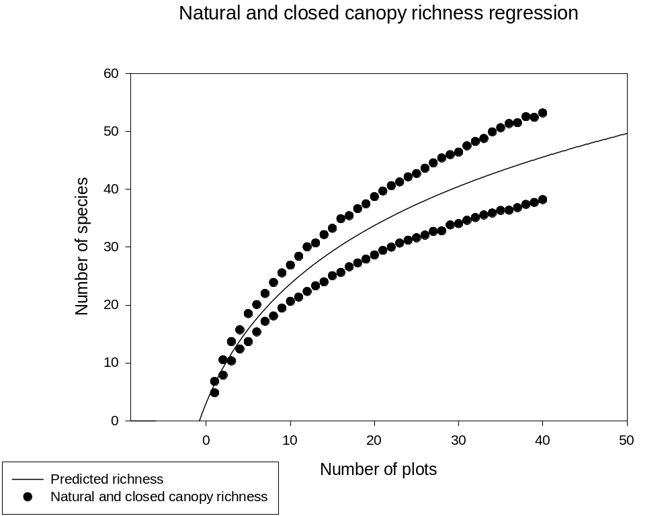

Natural and closed canopy nlin regression results

Nonlinear Regression

[Variables]
x = col(1)
y = col(3)
'Automatic Initial Parameter Estimate Functions
F(q)=ape(ln(x-x0est(q)),y,1,0,1)
x0est(q)=min(q) - 0.5
[Parameters]
a = F(0)[2] ''Auto {{previous: 20.5893}}
x0 = x0est(x) ' {{previous: -5.83202}}
y0 = F(0)[1] ' {{previous: -33.2032}}
[Equation]
f=if(x-x0>0, y0+a*ln(abs(x-x0)), 0)
fit f to y
[Constraints]
[Options]
tolerance=1e-4
stepsize=1
iterations=100

R = 0.90126463 Rsqr = 0.81227793 Adj Rsqr = 0.80740203

Standard Error of Estimate = 5.2744

Coefficient Std. Error t P
a 20.5893 4.2481 4.8467 <0.0001
x0 -5.8320 3.5166 -1.6584 0.1013
y0 -33.2032 16.8583 -1.9695 0.0525

Analysis of Variance:
DF SS MS F P
Regression 2 9268.8388 4634.4194 166.5904 <0.0001
Residual 77 2142.0816 27.8192
Total 79 11410.9204 144.4420

PRESS = 2278.1882

Durbin-Watson Statistic = 0.0322

Normality Test: Failed (P = 0.0015)

Constant Variance Test: Failed (P = <0.0001)

Power of performed test with alpha = 0.0500: 1.0000

Regression Diagnostics:
Row Predicted Residual Std. Res. Stud. Res. Stud. Del. Res.
1 6.3615 -1.5115 -0.2866 -0.3281 -0.3261
2 9.1740 -1.3040 -0.2472 -0.2638 -0.2622
3 11.6481 -1.2981 -0.2461 -0.2553 -0.2538
4 13.8565 -1.4465 -0.2743 -0.2812 -0.2795
5 15.8508 -2.1808 -0.4135 -0.4219 -0.4197
6 17.6689 -2.3189 -0.4397 -0.4479 -0.4455
7 19.3394 -2.1594 -0.4094 -0.4168 -0.4146
8 20.8845 -2.7645 -0.5241 -0.5335 -0.5311
9 22.3217 -2.8617 -0.5426 -0.5522 -0.5497
10 23.6650 -3.0350 -0.5754 -0.5855 -0.5829
11 24.9261 -3.5561 -0.6742 -0.6856 -0.6832
12 26.1143 -3.7843 -0.7175 -0.7291 -0.7269
13 27.2378 -3.9278 -0.7447 -0.7561 -0.7540
14 28.3030 -4.3030 -0.8158 -0.8276 -0.8259
15 29.3159 -4.2659 -0.8088 -0.8197 -0.8179
16 30.2812 -4.6612 -0.8837 -0.8948 -0.8937
17 31.2034 -4.6034 -0.8728 -0.8829 -0.8816
18 32.0859 -4.8159 -0.9131 -0.9229 -0.9220
19 32.9322 -5.0222 -0.9522 -0.9618 -0.9613
20 33.7451 -5.1051 -0.9679 -0.9770 -0.9767
21 34.5271 -5.1071 -0.9683 -0.9769 -0.9766
22 35.2805 -5.2905 -1.0031 -1.0117 -1.0118
23 36.0073 -5.3073 -1.0062 -1.0147 -1.0148
24 36.7093 -5.5193 -1.0464 -1.0551 -1.0559
25 37.3882 -5.7782 -1.0955 -1.1047 -1.1063
26 38.0453 -5.9753 -1.1329 -1.1427 -1.1450
27 38.6822 -5.9822 -1.1342 -1.1444 -1.1468
28 39.3000 -6.5000 -1.2324 -1.2442 -1.2487
29 39.8997 -6.0897 -1.1546 -1.1664 -1.1692
30 40.4825 -6.4225 -1.2177 -1.2312 -1.2354
31 41.0492 -6.4292 -1.2189 -1.2338 -1.2380
32 41.6008 -6.5008 -1.2325 -1.2489 -1.2535
33 42.1379 -6.5979 -1.2509 -1.2692 -1.2744
34 42.6614 -6.7714 -1.2838 -1.3045 -1.3105
35 43.1719 -6.8319 -1.2953 -1.3182 -1.3246
36 43.6701 -7.3001 -1.3841 -1.4109 -1.4202
37 44.1565 -7.3365 -1.3910 -1.4206 -1.4302
38 44.6317 -7.2517 -1.3749 -1.4069 -1.4160
39 45.0961 -7.3861 -1.4004 -1.4360 -1.4461
40 45.5503 -7.3403 -1.3917 -1.4302 -1.4402
41 6.3615 0.4285 0.0812 0.0930 0.0924
42 9.1740 1.3560 0.2571 0.2744 0.2727
43 11.6481 2.0219 0.3833 0.3977 0.3955
44 13.8565 1.8535 0.3514 0.3603 0.3583
45 15.8508 2.6492 0.5023 0.5125 0.5101
46 17.6689 2.3911 0.4533 0.4618 0.4594
47 19.3394 2.6506 0.5025 0.5117 0.5092
48 20.8845 3.0055 0.5698 0.5801 0.5776
49 22.3217 3.2383 0.6140 0.6249 0.6224
50 23.6650 3.2150 0.6095 0.6202 0.6177
51 24.9261 3.4839 0.6605 0.6717 0.6693
52 26.1143 3.9257 0.7443 0.7563 0.7542
53 27.2378 3.4722 0.6583 0.6684 0.6660
54 28.3030 3.8470 0.7294 0.7399 0.7377
55 29.3159 3.9341 0.7459 0.7559 0.7538
56 30.2812 4.6188 0.8757 0.8867 0.8854
57 31.2034 4.2166 0.7995 0.8088 0.8069
58 32.0859 4.5541 0.8634 0.8728 0.8714
59 32.9322 4.5378 0.8603 0.8690 0.8676
60 33.7451 4.9749 0.9432 0.9521 0.9515
61 34.5271 5.1429 0.9751 0.9838 0.9836
62 35.2805 5.3195 1.0086 1.0172 1.0174
63 36.0073 5.2427 0.9940 1.0023 1.0023
64 36.7093 5.4207 1.0277 1.0363 1.0368
65 37.3882 5.3018 1.0052 1.0136 1.0138
66 38.0453 5.5747 1.0569 1.0660 1.0670
67 38.6822 5.8578 1.1106 1.1206 1.1225
68 39.3000 6.1100 1.1584 1.1695 1.1724
69 39.8997 6.0703 1.1509 1.1627 1.1654
70 40.4825 5.9175 1.1219 1.1344 1.1366
71 41.0492 6.4508 1.2230 1.2379 1.2423
72 41.6008 6.6492 1.2607 1.2774 1.2828
73 42.1379 6.6321 1.2574 1.2758 1.2811
74 42.6614 7.2286 1.3705 1.3925 1.4012
75 43.1719 7.4381 1.4102 1.4351 1.4452
76 43.6701 7.6699 1.4542 1.4824 1.4942
77 44.1565 7.3135 1.3866 1.4161 1.4256
78 44.6317 7.8783 1.4937 1.5285 1.5421
79 45.0961 7.3239 1.3886 1.4239 1.4336
80 45.5503 7.6197 1.4446 1.4847 1.4966

Influence Diagnostics:
Row Cook'sDist Leverage DFFITS
1 0.0111 0.2369 -0.1817
2 0.0032 0.1219 -0.0977
3 0.0017 0.0709 -0.0701
4 0.0014 0.0487 -0.0633
5 0.0024 0.0396 -0.0853
6 0.0025 0.0363 -0.0865
7 0.0021 0.0353 -0.0793
8 0.0034 0.0350 -0.1011
9 0.0036 0.0346 -0.1041
10 0.0040 0.0340 -0.1093
11 0.0053 0.0330 -0.1261
12 0.0058 0.0316 -0.1313
13 0.0059 0.0300 -0.1326
14 0.0066 0.0283 -0.1408
15 0.0061 0.0264 -0.1348
16 0.0067 0.0246 -0.1420
17 0.0061 0.0229 -0.1349
18 0.0062 0.0213 -0.1359
19 0.0062 0.0198 -0.1367
20 0.0060 0.0186 -0.1345
21 0.0057 0.0176 -0.1309
22 0.0059 0.0169 -0.1328
23 0.0058 0.0165 -0.1315
24 0.0062 0.0164 -0.1363
25 0.0068 0.0166 -0.1435
26 0.0075 0.0170 -0.1507
27 0.0079 0.0178 -0.1544
28 0.0099 0.0189 -0.1732
29 0.0094 0.0202 -0.1681
30 0.0113 0.0219 -0.1849
31 0.0124 0.0239 -0.1936
32 0.0139 0.0261 -0.2052
33 0.0158 0.0286 -0.2187
34 0.0184 0.0314 -0.2359
35 0.0206 0.0344 -0.2501
36 0.0260 0.0377 -0.2811
37 0.0289 0.0412 -0.2965
38 0.0311 0.0450 -0.3073
39 0.0354 0.0490 -0.3281
40 0.0383 0.0532 -0.3413
41 0.0009 0.2369 0.0515
42 0.0035 0.1219 0.1016
43 0.0040 0.0709 0.1093
44 0.0022 0.0487 0.0811
45 0.0036 0.0396 0.1036
46 0.0027 0.0363 0.0892
47 0.0032 0.0353 0.0974
48 0.0041 0.0350 0.1099
49 0.0047 0.0346 0.1179
50 0.0045 0.0340 0.1158
51 0.0051 0.0330 0.1236
52 0.0062 0.0316 0.1363
53 0.0046 0.0300 0.1172
54 0.0053 0.0283 0.1258
55 0.0052 0.0264 0.1242
56 0.0066 0.0246 0.1406
57 0.0051 0.0229 0.1234
58 0.0055 0.0213 0.1284
59 0.0051 0.0198 0.1234
60 0.0057 0.0186 0.1310
61 0.0058 0.0176 0.1318
62 0.0059 0.0169 0.1335
63 0.0056 0.0165 0.1299
64 0.0060 0.0164 0.1338
65 0.0058 0.0166 0.1315
66 0.0066 0.0170 0.1404
67 0.0076 0.0178 0.1511
68 0.0088 0.0189 0.1626
69 0.0093 0.0202 0.1675
70 0.0096 0.0219 0.1701
71 0.0125 0.0239 0.1942
72 0.0146 0.0261 0.2100
73 0.0160 0.0286 0.2198
74 0.0209 0.0314 0.2522
75 0.0245 0.0344 0.2728
76 0.0287 0.0377 0.2957
77 0.0287 0.0412 0.2956
78 0.0367 0.0450 0.3347
79 0.0348 0.0490 0.3253
80 0.0413 0.0532 0.3546

95% Confidence:
Row Predicted Regr. 5% Regr. 95% Pop. 5% Pop. 95%
1 6.3615 1.2498 11.4732 -5.3190 18.0421
2 9.1740 5.5073 12.8407 -1.9503 20.2983
3 11.6481 8.8511 14.4450 0.7794 22.5168
4 13.8565 11.5376 16.1754 3.1009 24.6121
5 15.8508 13.7595 17.9421 5.1420 26.5597
6 17.6689 15.6675 19.6704 6.9772 28.3606
7 19.3394 17.3662 21.3126 8.6530 30.0258
8 20.8845 18.9203 22.8486 10.1997 31.5692
9 22.3217 20.3673 24.2760 11.6387 33.0046
10 23.6650 21.7291 25.6010 12.9854 34.3446
11 24.9261 23.0193 26.8329 14.2517 35.6004
12 26.1143 24.2469 27.9818 15.4470 36.7817
13 27.2378 25.4181 29.0574 16.5786 37.8969
14 28.3030 26.5375 30.0686 17.6530 38.9531
15 29.3159 27.6084 31.0234 18.6753 39.9564
16 30.2812 28.6336 31.9289 19.6501 40.9124
17 31.2034 29.6152 32.7915 20.5813 41.8254
18 32.0859 30.5547 33.6171 21.4722 42.6996
19 32.9322 31.4535 34.4110 22.3260 43.5385
20 33.7451 32.3124 35.1779 23.1452 44.3451
21 34.5271 33.1322 35.9221 23.9322 45.1220
22 35.2805 33.9137 36.6474 24.6893 45.8717
23 36.0073 34.6576 37.3570 25.4183 46.5963
24 36.7093 35.3649 38.0537 26.1209 47.2977
25 37.3882 36.0368 38.7395 26.7989 47.9774
26 38.0453 36.6749 39.4158 27.4536 48.6370
27 38.6822 37.2809 40.0835 28.0865 49.2779
28 39.3000 37.8570 40.7429 28.6986 49.9013
29 39.8997 38.4052 41.3942 29.2913 50.5082
30 40.4825 38.9278 42.0372 29.8654 51.0996
31 41.0492 39.4267 42.6717 30.4220 51.6765
32 41.6008 39.9041 43.2975 30.9619 52.2396
33 42.1379 40.3616 43.9143 31.4861 52.7897
34 42.6614 40.8010 44.5219 31.9953 53.3276
35 43.1719 41.2237 45.1202 32.4901 53.8538
36 43.6701 41.6311 45.7092 32.9713 54.3689
37 44.1565 42.0243 46.2888 33.4396 54.8734
38 44.6317 42.4043 46.8591 33.8954 55.3679
39 45.0961 42.7722 47.4201 34.3394 55.8528
40 45.5503 43.1287 47.9720 34.7721 56.3286
41 6.3615 1.2498 11.4732 -5.3190 18.0421
42 9.1740 5.5073 12.8407 -1.9503 20.2983
43 11.6481 8.8511 14.4450 0.7794 22.5168
44 13.8565 11.5376 16.1754 3.1009 24.6121
45 15.8508 13.7595 17.9421 5.1420 26.5597
46 17.6689 15.6675 19.6704 6.9772 28.3606
47 19.3394 17.3662 21.3126 8.6530 30.0258
48 20.8845 18.9203 22.8486 10.1997 31.5692
49 22.3217 20.3673 24.2760 11.6387 33.0046
50 23.6650 21.7291 25.6010 12.9854 34.3446
51 24.9261 23.0193 26.8329 14.2517 35.6004
52 26.1143 24.2469 27.9818 15.4470 36.7817
53 27.2378 25.4181 29.0574 16.5786 37.8969
54 28.3030 26.5375 30.0686 17.6530 38.9531
55 29.3159 27.6084 31.0234 18.6753 39.9564
56 30.2812 28.6336 31.9289 19.6501 40.9124
57 31.2034 29.6152 32.7915 20.5813 41.8254
58 32.0859 30.5547 33.6171 21.4722 42.6996
59 32.9322 31.4535 34.4110 22.3260 43.5385
60 33.7451 32.3124 35.1779 23.1452 44.3451
61 34.5271 33.1322 35.9221 23.9322 45.1220
62 35.2805 33.9137 36.6474 24.6893 45.8717
63 36.0073 34.6576 37.3570 25.4183 46.5963
64 36.7093 35.3649 38.0537 26.1209 47.2977
65 37.3882 36.0368 38.7395 26.7989 47.9774
66 38.0453 36.6749 39.4158 27.4536 48.6370
67 38.6822 37.2809 40.0835 28.0865 49.2779
68 39.3000 37.8570 40.7429 28.6986 49.9013
69 39.8997 38.4052 41.3942 29.2913 50.5082
70 40.4825 38.9278 42.0372 29.8654 51.0996
71 41.0492 39.4267 42.6717 30.4220 51.6765
72 41.6008 39.9041 43.2975 30.9619 52.2396
73 42.1379 40.3616 43.9143 31.4861 52.7897
74 42.6614 40.8010 44.5219 31.9953 53.3276
75 43.1719 41.2237 45.1202 32.4901 53.8538
76 43.6701 41.6311 45.7092 32.9713 54.3689
77 44.1565 42.0243 46.2888 33.4396 54.8734
78 44.6317 42.4043 46.8591 33.8954 55.3679
79 45.0961 42.7722 47.4201 34.3394 55.8528
80 45.5503 43.1287 47.9720 34.7721 56.3286

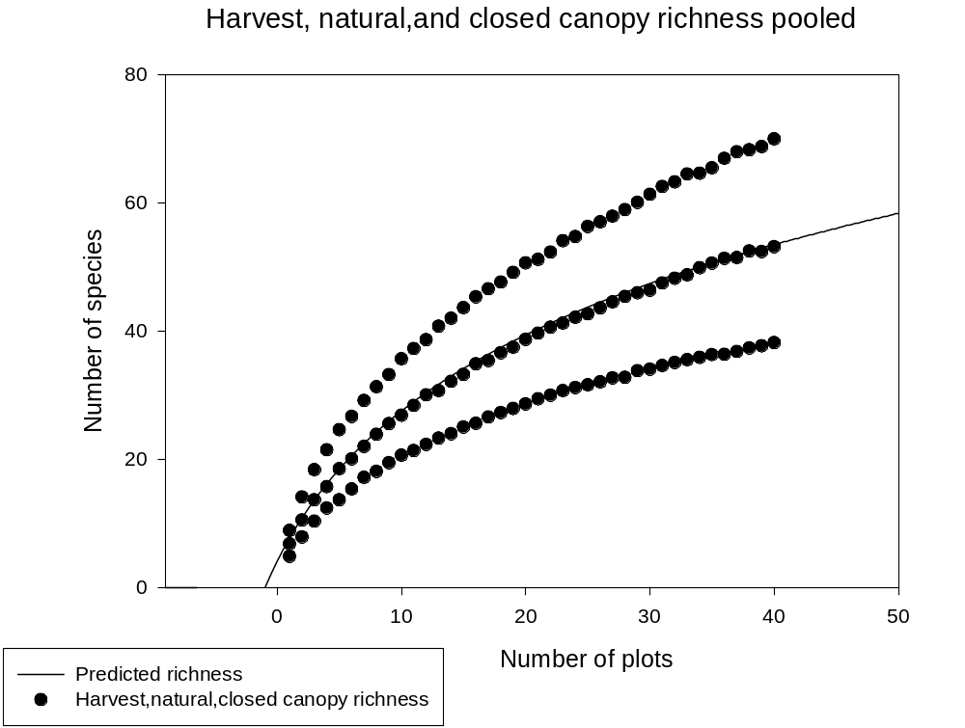

Harvest gap, natural gap, and closed canopy richness pooled regression model

Nonlinear Regression

[Variables]
x = col(4)
y = col(5)
'Automatic Initial Parameter Estimate Functions
F(q)=ape(ln(x-x0est(q)),y,1,0,1)
x0est(q)=min(q) - 0.5
[Parameters]
a = F(0)[2] ''Auto {{previous: 25.0013}}
x0 = x0est(x) ' {{previous: -6.43266}}
y0 = F(0)[1] ' {{previous: -42.4612}}
[Equation]
f=if(x-x0>0, y0+a*ln(abs(x-x0)), 0)
fit f to y
[Constraints]
[Options]
tolerance=1e-4
stepsize=1
iterations=100

R = 0.81168567 Rsqr = 0.65883363 Adj Rsqr = 0.65300172

Standard Error of Estimate = 9.2166

Coefficient Std. Error t P
a 25.0013 6.4564 3.8724 0.0002
x0 -6.4327 4.6256 -1.3907 0.1670
y0 -42.4612 25.8489 -1.6427 0.1031

Analysis of Variance:
DF SS MS F P
Regression 2 19192.8767 9596.4383 112.9706 <0.0001
Residual 117 9938.7219 84.9463
Total 119 29131.5985 244.8033

PRESS = 10352.1158

Durbin-Watson Statistic = 0.0236

Normality Test: Failed (P = <0.0001)

Constant Variance Test: Failed (P = <0.0001)

Power of performed test with alpha = 0.0500: 1.0000

Regression Diagnostics:
Row Predicted Residual Std. Res. Stud. Res. Stud. Del. Res.
1 7.6885 -2.8385 -0.3080 -0.3348 -0.3335
2 10.8444 -2.9744 -0.3227 -0.3367 -0.3354
3 13.6462 -3.2962 -0.3576 -0.3665 -0.3651
4 16.1654 -3.7554 -0.4075 -0.4143 -0.4128
5 18.4539 -4.7839 -0.5190 -0.5260 -0.5244
6 20.5503 -5.2003 -0.5642 -0.5711 -0.5695
7 22.4845 -5.3045 -0.5755 -0.5823 -0.5807
8 24.2797 -6.1597 -0.6683 -0.6761 -0.6746
9 25.9546 -6.4946 -0.7047 -0.7129 -0.7113
10 27.5243 -6.8943 -0.7480 -0.7566 -0.7552
11 29.0012 -7.6312 -0.8280 -0.8372 -0.8361
12 30.3958 -8.0658 -0.8751 -0.8845 -0.8837
13 31.7166 -8.4066 -0.9121 -0.9215 -0.9209
14 32.9712 -8.9712 -0.9734 -0.9828 -0.9826
15 34.1658 -9.1158 -0.9891 -0.9980 -0.9980
16 35.3059 -9.6859 -1.0509 -1.0598 -1.0604
17 36.3963 -9.7963 -1.0629 -1.0712 -1.0719
18 37.4411 -10.1711 -1.1036 -1.1116 -1.1127
19 38.4440 -10.5340 -1.1429 -1.1507 -1.1523
20 39.4082 -10.7682 -1.1683 -1.1758 -1.1777
21 40.3366 -10.9166 -1.1844 -1.1916 -1.1938
22 41.2317 -11.2417 -1.2197 -1.2268 -1.2294
23 42.0959 -11.3959 -1.2365 -1.2434 -1.2463
24 42.9313 -11.7413 -1.2739 -1.2810 -1.2845
25 43.7396 -12.1296 -1.3161 -1.3234 -1.3277
26 44.5226 -12.4526 -1.3511 -1.3589 -1.3638
27 45.2818 -12.5818 -1.3651 -1.3733 -1.3786
28 46.0187 -13.2187 -1.4342 -1.4433 -1.4501
29 46.7344 -12.9244 -1.4023 -1.4118 -1.4179
30 47.4302 -13.3702 -1.4507 -1.4614 -1.4686
31 48.1072 -13.4872 -1.4634 -1.4751 -1.4827
32 48.7664 -13.6664 -1.4828 -1.4959 -1.5039
33 49.4086 -13.8686 -1.5047 -1.5193 -1.5280
34 50.0347 -14.1447 -1.5347 -1.5511 -1.5606
35 50.6455 -14.3055 -1.5521 -1.5704 -1.5804
36 51.2418 -14.8718 -1.6136 -1.6344 -1.6463
37 51.8241 -15.0041 -1.6279 -1.6510 -1.6635
38 52.3932 -15.0132 -1.6289 -1.6543 -1.6668
39 52.9497 -15.2397 -1.6535 -1.6816 -1.6950
40 53.4940 -15.2840 -1.6583 -1.6890 -1.7027
41 7.6885 -0.8985 -0.0975 -0.1060 -0.1055
42 10.8444 -0.3144 -0.0341 -0.0356 -0.0354
43 13.6462 0.0238 0.0026 0.0026 0.0026
44 16.1654 -0.4554 -0.0494 -0.0502 -0.0500
45 18.4539 0.0461 0.0050 0.0051 0.0050
46 20.5503 -0.4903 -0.0532 -0.0538 -0.0536
47 22.4845 -0.4945 -0.0537 -0.0543 -0.0541
48 24.2797 -0.3897 -0.0423 -0.0428 -0.0426
49 25.9546 -0.3946 -0.0428 -0.0433 -0.0431
50 27.5243 -0.6443 -0.0699 -0.0707 -0.0704
51 29.0012 -0.5912 -0.0641 -0.0649 -0.0646
52 30.3958 -0.3558 -0.0386 -0.0390 -0.0388
53 31.7166 -1.0066 -0.1092 -0.1103 -0.1099
54 32.9712 -0.8212 -0.0891 -0.0900 -0.0896
55 34.1658 -0.9158 -0.0994 -0.1003 -0.0998
56 35.3059 -0.4059 -0.0440 -0.0444 -0.0442
57 36.3963 -0.9763 -0.1059 -0.1068 -0.1063
58 37.4411 -0.8011 -0.0869 -0.0876 -0.0872
59 38.4440 -0.9740 -0.1057 -0.1064 -0.1059
60 39.4082 -0.6882 -0.0747 -0.0751 -0.0748
61 40.3366 -0.6666 -0.0723 -0.0728 -0.0724
62 41.2317 -0.6317 -0.0685 -0.0689 -0.0686
63 42.0959 -0.8459 -0.0918 -0.0923 -0.0919
64 42.9313 -0.8013 -0.0869 -0.0874 -0.0870
65 43.7396 -1.0496 -0.1139 -0.1145 -0.1140
66 44.5226 -0.9026 -0.0979 -0.0985 -0.0981
67 45.2818 -0.7418 -0.0805 -0.0810 -0.0806
68 46.0187 -0.6087 -0.0660 -0.0665 -0.0662
69 46.7344 -0.7644 -0.0829 -0.0835 -0.0831
70 47.4302 -1.0302 -0.1118 -0.1126 -0.1121
71 48.1072 -0.6072 -0.0659 -0.0664 -0.0661
72 48.7664 -0.5164 -0.0560 -0.0565 -0.0563
73 49.4086 -0.6386 -0.0693 -0.0700 -0.0697
74 50.0347 -0.1447 -0.0157 -0.0159 -0.0158
75 50.6455 -0.0355 -0.0039 -0.0039 -0.0039
76 51.2418 0.0982 0.0107 0.0108 0.0108
77 51.8241 -0.3541 -0.0384 -0.0390 -0.0388
78 52.3932 0.1168 0.0127 0.0129 0.0128
79 52.9497 -0.5297 -0.0575 -0.0584 -0.0582
80 53.4940 -0.3240 -0.0352 -0.0358 -0.0357
81 7.6885 1.1915 0.1293 0.1405 0.1399
82 10.8444 3.2656 0.3543 0.3696 0.3683
83 13.6462 4.7138 0.5114 0.5241 0.5225
84 16.1654 5.3146 0.5766 0.5863 0.5847
85 18.4539 6.1561 0.6679 0.6769 0.6753
86 20.5503 6.1397 0.6662 0.6743 0.6727
87 22.4845 6.6855 0.7254 0.7339 0.7325
88 24.2797 7.0203 0.7617 0.7706 0.7693
89 25.9546 7.2454 0.7861 0.7953 0.7940
90 27.5243 8.1557 0.8849 0.8950 0.8943
91 29.0012 8.2588 0.8961 0.9061 0.9054
92 30.3958 8.2742 0.8977 0.9074 0.9067
93 31.7166 9.0534 0.9823 0.9923 0.9923
94 32.9712 9.0188 0.9785 0.9880 0.9879
95 34.1658 9.5142 1.0323 1.0416 1.0420
96 35.3059 10.0441 1.0898 1.0990 1.1000
97 36.3963 10.1937 1.1060 1.1147 1.1159
98 37.4411 10.2089 1.1077 1.1158 1.1169
99 38.4440 10.7160 1.1627 1.1706 1.1725
100 39.4082 11.2418 1.2197 1.2275 1.2302
101 40.3366 10.8434 1.1765 1.1836 1.1857
102 41.2317 11.1083 1.2052 1.2122 1.2147
103 42.0959 12.0041 1.3024 1.3097 1.3138
104 42.9313 11.8187 1.2823 1.2894 1.2931
105 43.7396 12.6004 1.3671 1.3748 1.3801
106 44.5226 12.5174 1.3581 1.3659 1.3711
107 45.2818 12.6482 1.3723 1.3805 1.3860
108 46.0187 12.9513 1.4052 1.4141 1.4203
109 46.7344 13.3756 1.4512 1.4611 1.4683
110 47.4302 13.9098 1.5092 1.5203 1.5290
111 48.1072 14.4728 1.5703 1.5829 1.5933
112 48.7664 14.5236 1.5758 1.5897 1.6003
113 49.4086 15.1114 1.6396 1.6555 1.6680
114 50.0347 14.6053 1.5847 1.6016 1.6125
115 50.6455 14.8345 1.6095 1.6284 1.6402
116 51.2418 15.7282 1.7065 1.7286 1.7436
117 51.8241 16.1559 1.7529 1.7778 1.7946
118 52.3932 15.9268 1.7280 1.7549 1.7709
119 52.9497 15.8303 1.7176 1.7468 1.7624
120 53.4940 16.4960 1.7898 1.8230 1.8415

Influence Diagnostics:
Row Cook'sDist Leverage DFFITS
1 0.0068 0.1536 -0.1421
2 0.0033 0.0811 -0.0997
3 0.0022 0.0478 -0.0818
4 0.0019 0.0328 -0.0760
5 0.0025 0.0264 -0.0863
6 0.0027 0.0240 -0.0892
7 0.0027 0.0232 -0.0895
8 0.0036 0.0230 -0.1035
9 0.0040 0.0229 -0.1088
10 0.0044 0.0225 -0.1146
11 0.0052 0.0219 -0.1253
12 0.0056 0.0211 -0.1299
13 0.0058 0.0202 -0.1321
14 0.0063 0.0191 -0.1370
15 0.0060 0.0179 -0.1347
16 0.0064 0.0167 -0.1381
17 0.0060 0.0155 -0.1346
18 0.0060 0.0145 -0.1347
19 0.0060 0.0135 -0.1347
20 0.0059 0.0126 -0.1333
21 0.0057 0.0120 -0.1313
22 0.0058 0.0115 -0.1323
23 0.0058 0.0111 -0.1323
24 0.0061 0.0110 -0.1356
25 0.0065 0.0111 -0.1406
26 0.0071 0.0114 -0.1463
27 0.0076 0.0119 -0.1511
28 0.0088 0.0126 -0.1636
29 0.0091 0.0135 -0.1657
30 0.0105 0.0146 -0.1787
31 0.0117 0.0159 -0.1885
32 0.0132 0.0174 -0.2002
33 0.0150 0.0191 -0.2133
34 0.0172 0.0210 -0.2286
35 0.0194 0.0231 -0.2430
36 0.0232 0.0254 -0.2655
37 0.0260 0.0278 -0.2812
38 0.0286 0.0304 -0.2950
39 0.0323 0.0331 -0.3138
40 0.0356 0.0361 -0.3293
41 0.0007 0.1536 -0.0450
42 0.0000 0.0811 -0.0105
43 0.0000 0.0478 0.0006
44 0.0000 0.0328 -0.0092
45 0.0000 0.0264 0.0008
46 0.0000 0.0240 -0.0084
47 0.0000 0.0232 -0.0083
48 0.0000 0.0230 -0.0065
49 0.0000 0.0229 -0.0066
50 0.0000 0.0225 -0.0107
51 0.0000 0.0219 -0.0097
52 0.0000 0.0211 -0.0057
53 0.0001 0.0202 -0.0158
54 0.0001 0.0191 -0.0125
55 0.0001 0.0179 -0.0135
56 0.0000 0.0167 -0.0058
57 0.0001 0.0155 -0.0134
58 0.0000 0.0145 -0.0106
59 0.0001 0.0135 -0.0124
60 0.0000 0.0126 -0.0085
61 0.0000 0.0120 -0.0080
62 0.0000 0.0115 -0.0074
63 0.0000 0.0111 -0.0098
64 0.0000 0.0110 -0.0092
65 0.0000 0.0111 -0.0121
66 0.0000 0.0114 -0.0105
67 0.0000 0.0119 -0.0088
68 0.0000 0.0126 -0.0075
69 0.0000 0.0135 -0.0097
70 0.0001 0.0146 -0.0136
71 0.0000 0.0159 -0.0084
72 0.0000 0.0174 -0.0075
73 0.0000 0.0191 -0.0097
74 0.0000 0.0210 -0.0023
75 0.0000 0.0231 -0.0006
76 0.0000 0.0254 0.0017
77 0.0000 0.0278 -0.0066
78 0.0000 0.0304 0.0023
79 0.0000 0.0331 -0.0108
80 0.0000 0.0361 -0.0069
81 0.0012 0.1536 0.0596
82 0.0040 0.0811 0.1094
83 0.0046 0.0478 0.1170
84 0.0039 0.0328 0.1076
85 0.0041 0.0264 0.1112
86 0.0037 0.0240 0.1054
87 0.0043 0.0232 0.1129
88 0.0047 0.0230 0.1180
89 0.0049 0.0229 0.1214
90 0.0062 0.0225 0.1357
91 0.0061 0.0219 0.1356
92 0.0059 0.0211 0.1333
93 0.0068 0.0202 0.1424
94 0.0063 0.0191 0.1377
95 0.0066 0.0179 0.1406
96 0.0068 0.0167 0.1433
97 0.0065 0.0155 0.1402
98 0.0061 0.0145 0.1352
99 0.0062 0.0135 0.1370
100 0.0064 0.0126 0.1392
101 0.0057 0.0120 0.1304
102 0.0057 0.0115 0.1308
103 0.0064 0.0111 0.1394
104 0.0062 0.0110 0.1365
105 0.0071 0.0111 0.1462
106 0.0072 0.0114 0.1471
107 0.0076 0.0119 0.1519
108 0.0085 0.0126 0.1603
109 0.0097 0.0135 0.1716
110 0.0114 0.0146 0.1861
111 0.0135 0.0159 0.2026
112 0.0149 0.0174 0.2131
113 0.0178 0.0191 0.2329
114 0.0184 0.0210 0.2363
115 0.0209 0.0231 0.2522
116 0.0259 0.0254 0.2812
117 0.0301 0.0278 0.3034
118 0.0322 0.0304 0.3135
119 0.0349 0.0331 0.3263
120 0.0414 0.0361 0.3562

95% Confidence:
Row Predicted Regr. 5% Regr. 95% Pop. 5% Pop. 95%
1 7.6885 0.5346 14.8425 -11.9164 27.2935
2 10.8444 5.6454 16.0434 -8.1346 29.8235
3 13.6462 9.6563 17.6362 -5.0378 32.3303
4 16.1654 12.8615 19.4694 -2.3842 34.7151
5 18.4539 15.4893 21.4185 -0.0384 36.9461
6 20.5503 17.7253 23.3754 2.0799 39.0207
7 22.4845 19.7042 25.2647 4.0209 40.9481
8 24.2797 21.5111 27.0483 5.8179 42.7415
9 25.9546 23.1953 28.7138 7.4942 44.4150
10 27.5243 24.7851 30.2635 9.0668 45.9817
11 29.0012 26.2970 31.7054 10.5489 47.4535
12 30.3958 27.7413 33.0503 11.9507 48.8408
13 31.7166 29.1246 34.3087 13.2804 50.1528
14 32.9712 30.4514 35.4909 14.5450 51.3973
15 34.1658 31.7251 36.6065 15.7503 52.5813
16 35.3059 32.9479 37.6639 16.9011 53.7106
17 36.3963 34.1214 38.6711 18.0020 54.7905
18 37.4411 35.2469 39.6353 19.0566 55.8255
19 38.4440 36.3249 40.5630 20.0683 56.8196
20 39.4082 37.3560 41.4603 21.0401 57.7762
21 40.3366 38.3404 42.3328 21.9747 58.6985
22 41.2317 39.2782 43.1853 22.8744 59.5890
23 42.0959 40.1698 44.0221 23.7415 60.4503
24 42.9313 41.0158 44.8468 24.5780 61.2846
25 43.7396 41.8172 45.6620 25.3856 62.0936
26 44.5226 42.5756 46.4695 26.1660 62.8792
27 45.2818 43.2931 47.2705 26.9207 63.6429
28 46.0187 43.9721 48.0652 27.6512 64.3861
29 46.7344 44.6153 48.8536 28.3587 65.1101
30 47.4302 45.2254 49.6351 29.0445 65.8160
31 48.1072 45.8052 50.4092 29.7096 66.5049
32 48.7664 46.3575 51.1752 30.3550 67.1777
33 49.4086 46.8845 51.9326 30.9818 67.8353
34 50.0347 47.3886 52.6808 31.5908 68.4785
35 50.6455 47.8716 53.4194 32.1829 69.1081
36 51.2418 48.3355 54.1480 32.7588 69.7247
37 51.8241 48.7817 54.8665 33.3193 70.3290
38 52.3932 49.2117 55.5748 33.8650 70.9215
39 52.9497 49.6267 56.2727 34.3966 71.5028
40 53.4940 50.0277 56.9603 34.9147 72.0733
41 7.6885 0.5346 14.8425 -11.9164 27.2935
42 10.8444 5.6454 16.0434 -8.1346 29.8235
43 13.6462 9.6563 17.6362 -5.0378 32.3303
44 16.1654 12.8615 19.4694 -2.3842 34.7151
45 18.4539 15.4893 21.4185 -0.0384 36.9461
46 20.5503 17.7253 23.3754 2.0799 39.0207
47 22.4845 19.7042 25.2647 4.0209 40.9481
48 24.2797 21.5111 27.0483 5.8179 42.7415
49 25.9546 23.1953 28.7138 7.4942 44.4150
50 27.5243 24.7851 30.2635 9.0668 45.9817
51 29.0012 26.2970 31.7054 10.5489 47.4535
52 30.3958 27.7413 33.0503 11.9507 48.8408
53 31.7166 29.1246 34.3087 13.2804 50.1528
54 32.9712 30.4514 35.4909 14.5450 51.3973
55 34.1658 31.7251 36.6065 15.7503 52.5813
56 35.3059 32.9479 37.6639 16.9011 53.7106
57 36.3963 34.1214 38.6711 18.0020 54.7905
58 37.4411 35.2469 39.6353 19.0566 55.8255
59 38.4440 36.3249 40.5630 20.0683 56.8196
60 39.4082 37.3560 41.4603 21.0401 57.7762
61 40.3366 38.3404 42.3328 21.9747 58.6985
62 41.2317 39.2782 43.1853 22.8744 59.5890
63 42.0959 40.1698 44.0221 23.7415 60.4503
64 42.9313 41.0158 44.8468 24.5780 61.2846
65 43.7396 41.8172 45.6620 25.3856 62.0936
66 44.5226 42.5756 46.4695 26.1660 62.8792
67 45.2818 43.2931 47.2705 26.9207 63.6429
68 46.0187 43.9721 48.0652 27.6512 64.3861
69 46.7344 44.6153 48.8536 28.3587 65.1101
70 47.4302 45.2254 49.6351 29.0445 65.8160
71 48.1072 45.8052 50.4092 29.7096 66.5049
72 48.7664 46.3575 51.1752 30.3550 67.1777
73 49.4086 46.8845 51.9326 30.9818 67.8353
74 50.0347 47.3886 52.6808 31.5908 68.4785
75 50.6455 47.8716 53.4194 32.1829 69.1081
76 51.2418 48.3355 54.1480 32.7588 69.7247
77 51.8241 48.7817 54.8665 33.3193 70.3290
78 52.3932 49.2117 55.5748 33.8650 70.9215
79 52.9497 49.6267 56.2727 34.3966 71.5028
80 53.4940 50.0277 56.9603 34.9147 72.0733
81 7.6885 0.5346 14.8425 -11.9164 27.2935
82 10.8444 5.6454 16.0434 -8.1346 29.8235
83 13.6462 9.6563 17.6362 -5.0378 32.3303
84 16.1654 12.8615 19.4694 -2.3842 34.7151
85 18.4539 15.4893 21.4185 -0.0384 36.9461
86 20.5503 17.7253 23.3754 2.0799 39.0207
87 22.4845 19.7042 25.2647 4.0209 40.9481
88 24.2797 21.5111 27.0483 5.8179 42.7415
89 25.9546 23.1953 28.7138 7.4942 44.4150
90 27.5243 24.7851 30.2635 9.0668 45.9817
91 29.0012 26.2970 31.7054 10.5489 47.4535
92 30.3958 27.7413 33.0503 11.9507 48.8408
93 31.7166 29.1246 34.3087 13.2804 50.1528
94 32.9712 30.4514 35.4909 14.5450 51.3973
95 34.1658 31.7251 36.6065 15.7503 52.5813
96 35.3059 32.9479 37.6639 16.9011 53.7106
97 36.3963 34.1214 38.6711 18.0020 54.7905
98 37.4411 35.2469 39.6353 19.0566 55.8255
99 38.4440 36.3249 40.5630 20.0683 56.8196
100 39.4082 37.3560 41.4603 21.0401 57.7762
101 40.3366 38.3404 42.3328 21.9747 58.6985
102 41.2317 39.2782 43.1853 22.8744 59.5890
103 42.0959 40.1698 44.0221 23.7415 60.4503
104 42.9313 41.0158 44.8468 24.5780 61.2846
105 43.7396 41.8172 45.6620 25.3856 62.0936
106 44.5226 42.5756 46.4695 26.1660 62.8792
107 45.2818 43.2931 47.2705 26.9207 63.6429
108 46.0187 43.9721 48.0652 27.6512 64.3861
109 46.7344 44.6153 48.8536 28.3587 65.1101
110 47.4302 45.2254 49.6351 29.0445 65.8160
111 48.1072 45.8052 50.4092 29.7096 66.5049
112 48.7664 46.3575 51.1752 30.3550 67.1777
113 49.4086 46.8845 51.9326 30.9818 67.8353
114 50.0347 47.3886 52.6808 31.5908 68.4785
115 50.6455 47.8716 53.4194 32.1829 69.1081
116 51.2418 48.3355 54.1480 32.7588 69.7247
117 51.8241 48.7817 54.8665 33.3193 70.3290
118 52.3932 49.2117 55.5748 33.8650 70.9215
119 52.9497 49.6267 56.2727 34.3966 71.5028
120 53.4940 50.0277 56.9603 34.9147 72.0733

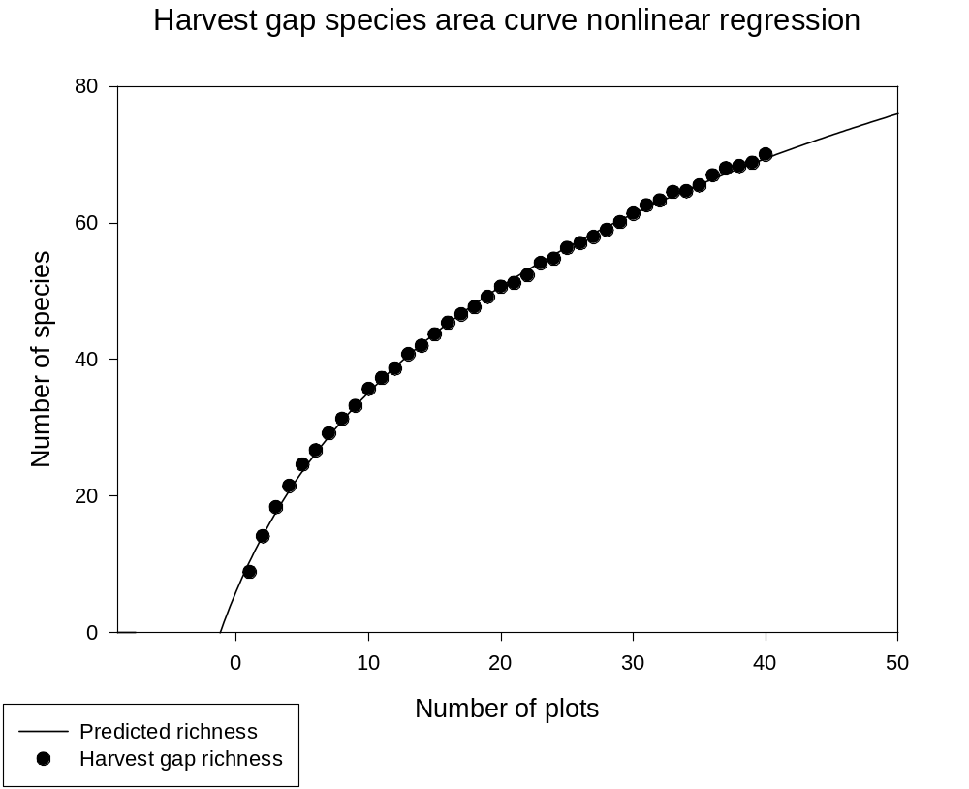

Harvest gap species area curve nonlinear regression

Nonlinear Regression

[Variables]
x = col(1)
y = col(2)
'Automatic Initial Parameter Estimate Functions
F(q)=ape(ln(x-x0est(q)),y,1,0,1)
x0est(q)=min(q) - 0.5
[Parameters]
a = F(0)[2] ''Auto {{previous: 34.2648}}
x0 = x0est(x) ' {{previous: -7.48625}}
y0 = F(0)[1] ' {{previous: -62.8451}}
[Equation]
f=if(x-x0>0, y0+a*ln(abs(x-x0)), 0)
fit f to y
[Constraints]
[Options]
tolerance=1e-4
stepsize=1
iterations=100

R = 0.99955677 Rsqr = 0.99911374 Adj Rsqr = 0.99906583

Standard Error of Estimate = 0.5083

Coefficient Std. Error t P
a 34.2648 0.7196 47.6192 <0.0001
x0 -7.4862 0.4115 -18.1938 <0.0001
y0 -62.8451 2.9421 -21.3607 <0.0001

Analysis of Variance:
DF SS MS F P
Regression 2 10777.5829 5388.7915 20855.7565 <0.0001
Residual 37 9.5602 0.2584
Total 39 10787.1431 276.5934

PRESS = 15.7314

Durbin-Watson Statistic = 0.7965

Normality Test: Passed (P = 0.7248)

Constant Variance Test: Passed (P = 0.7635)

Power of performed test with alpha = 0.0500: 1.0000

Regression Diagnostics:
Row Predicted Residual Std. Res. Stud. Res. Stud. Del. Res.
1 10.4284 -1.5484 -3.0461 -4.0425 -5.3365
2 14.2453 -0.1353 -0.2663 -0.3057 -0.3019
3 17.6794 0.6806 1.3389 1.4492 1.4719
4 20.8004 0.6796 1.3369 1.4094 1.4292
5 23.6608 0.9492 1.8674 1.9460 2.0259
6 26.3006 0.3894 0.7660 0.7944 0.7904
7 28.7516 0.4184 0.8232 0.8524 0.8492
8 31.0388 0.2612 0.5138 0.5318 0.5266
9 33.1829 0.0171 0.0336 0.0348 0.0343
10 35.2007 0.4793 0.9429 0.9758 0.9752
11 37.1063 0.1537 0.3024 0.3128 0.3090
12 38.9114 -0.2414 -0.4749 -0.4908 -0.4857
13 40.6262 0.1438 0.2829 0.2920 0.2884
14 42.2592 -0.2692 -0.5296 -0.5458 -0.5406
15 43.8180 -0.1380 -0.2714 -0.2792 -0.2757
16 45.3089 0.0411 0.0809 0.0831 0.0820
17 46.7376 -0.1476 -0.2903 -0.2977 -0.2940
18 48.1091 -0.4591 -0.9032 -0.9244 -0.9225
19 49.4279 -0.2679 -0.5269 -0.5385 -0.5332
20 50.6977 -0.0477 -0.0939 -0.0958 -0.0945
21 51.9222 -0.7422 -1.4601 -1.4882 -1.5139
22 53.1044 -0.7644 -1.5038 -1.5313 -1.5608
23 54.2472 -0.1472 -0.2896 -0.2947 -0.2910
24 55.3531 -0.6031 -1.1865 -1.2070 -1.2148
25 56.4244 -0.0844 -0.1661 -0.1690 -0.1667
26 57.4633 -0.4233 -0.8327 -0.8474 -0.8441
27 58.4715 -0.5415 -1.0654 -1.0849 -1.0876
28 59.4510 -0.4810 -0.9462 -0.9646 -0.9636
29 60.4032 -0.2932 -0.5768 -0.5888 -0.5835
30 61.3297 0.0103 0.0203 0.0207 0.0205
31 62.2318 0.3482 0.6851 0.7020 0.6971
32 63.1107 0.1793 0.3527 0.3623 0.3580
33 63.9677 0.5523 1.0866 1.1193 1.1233
34 64.8037 -0.1637 -0.3221 -0.3329 -0.3288
35 65.6199 -0.1399 -0.2751 -0.2854 -0.2818
36 66.4170 0.5530 1.0879 1.1327 1.1372
37 67.1960 0.7840 1.5423 1.6128 1.6499
38 67.9577 0.3623 0.7127 0.7487 0.7442
39 68.7029 0.0771 0.1517 0.1602 0.1581
40 69.4322 0.5578 1.0974 1.1650 1.1709

Influence Diagnostics:
Row Cook'sDist Leverage DFFITS
1 4.1467 0.4322 -4.6561
2 0.0099 0.2415 -0.1703
3 0.1201 0.1465 0.6097
4 0.0738 0.1003 0.4772
5 0.1085 0.0791 0.5939
6 0.0159 0.0704 0.2175
7 0.0175 0.0674 0.2283
8 0.0067 0.0668 0.1409
9 0.0000 0.0667 0.0092
10 0.0226 0.0664 0.2600
11 0.0023 0.0654 0.0817
12 0.0055 0.0637 -0.1266
13 0.0019 0.0613 0.0737
14 0.0062 0.0585 -0.1347
15 0.0015 0.0553 -0.0667
16 0.0001 0.0519 0.0192
17 0.0015 0.0486 -0.0664
18 0.0135 0.0453 -0.2010
19 0.0043 0.0423 -0.1121
20 0.0001 0.0396 -0.0192
21 0.0287 0.0374 -0.2983
22 0.0289 0.0356 -0.2999
23 0.0010 0.0344 -0.0549
24 0.0170 0.0337 -0.2270
25 0.0003 0.0337 -0.0312
26 0.0085 0.0344 -0.1593
27 0.0145 0.0357 -0.2092
28 0.0121 0.0376 -0.1906
29 0.0049 0.0403 -0.1196
30 0.0000 0.0436 0.0044
31 0.0082 0.0476 0.1559
32 0.0024 0.0523 0.0841
33 0.0256 0.0577 0.2779
34 0.0025 0.0637 -0.0857
35 0.0021 0.0703 -0.0775
36 0.0360 0.0776 0.3298
37 0.0810 0.0855 0.5044
38 0.0194 0.0940 0.2397
39 0.0010 0.1030 0.0536
40 0.0575 0.1127 0.4173

95% Confidence:
Row Predicted Regr. 5% Regr. 95% Pop. 5% Pop. 95%
1 10.4284 9.7512 11.1055 9.1958 11.6610
2 14.2453 13.7392 14.7514 13.0978 15.3929
3 17.6794 17.2853 18.0736 16.5766 18.7822
4 20.8004 20.4742 21.1267 19.7201 21.8808
5 23.6608 23.3711 23.9505 22.5909 24.7307
6 26.3006 26.0274 26.5739 25.2351 27.3662
7 28.7516 28.4841 29.0190 27.6875 29.8157
8 31.0388 30.7726 31.3050 29.9751 32.1026
9 33.1829 32.9169 33.4490 32.1192 34.2467
10 35.2007 34.9354 35.4661 34.1372 36.2643
11 37.1063 36.8430 37.3696 36.0432 38.1693
12 38.9114 38.6516 39.1713 37.8492 39.9736
13 40.6262 40.3712 40.8812 39.5651 41.6872
14 42.2592 42.0102 42.5083 41.1996 43.3188
15 43.8180 43.5758 44.0601 42.7599 44.8760
16 45.3089 45.0741 45.5436 44.2525 46.3652
17 46.7376 46.5106 46.9646 45.6829 47.7922
18 48.1091 47.8899 48.3284 47.0561 49.1621
19 49.4279 49.2160 49.6397 48.3764 50.4794
20 50.6977 50.4927 50.9027 49.6476 51.7479
21 51.9222 51.7231 52.1213 50.8732 52.9712
22 53.1044 52.9101 53.2987 52.0563 54.1525
23 54.2472 54.0562 54.4382 53.1997 55.2947
24 55.3531 55.1639 55.5423 54.3059 56.4003
25 56.4244 56.2353 56.6136 55.3773 57.4716
26 57.4633 57.2723 57.6542 56.4158 58.5108
27 58.4715 58.2770 58.6661 57.4234 59.5197
28 59.4510 59.2512 59.6508 58.4018 60.5001
29 60.4032 60.1965 60.6100 59.3527 61.4537
30 61.3297 61.1146 61.5448 60.2775 62.3819
31 62.2318 62.0070 62.4566 61.1776 63.2860
32 63.1107 62.8751 63.3463 62.0542 64.1673
33 63.9677 63.7203 64.2150 62.9084 65.0269
34 64.8037 64.5438 65.0636 63.7415 65.8660
35 65.6199 65.3467 65.8930 64.5543 66.6854
36 66.4170 66.1301 66.7039 65.3479 67.4862
37 67.1960 66.8949 67.4971 66.1230 68.2691
38 67.9577 67.6420 68.2735 66.8805 69.0350
39 68.7029 68.3723 69.0335 67.6212 69.7846
40 69.4322 69.0864 69.7779 68.3457 70.5186

